SUNPASS CUSTOMER SERVICE OPERATIONS – PERFORMANCE TREND REPORT
Overview
This dashboard summarizes key performance trends across August, September, and October.
It highlights how customer demand, service efficiency, and satisfaction shifted over time, using both monthly and weekly analysis.
The goal is to clearly communicate where performance improved and what drove those improvements.
- Monthly Performance Summary
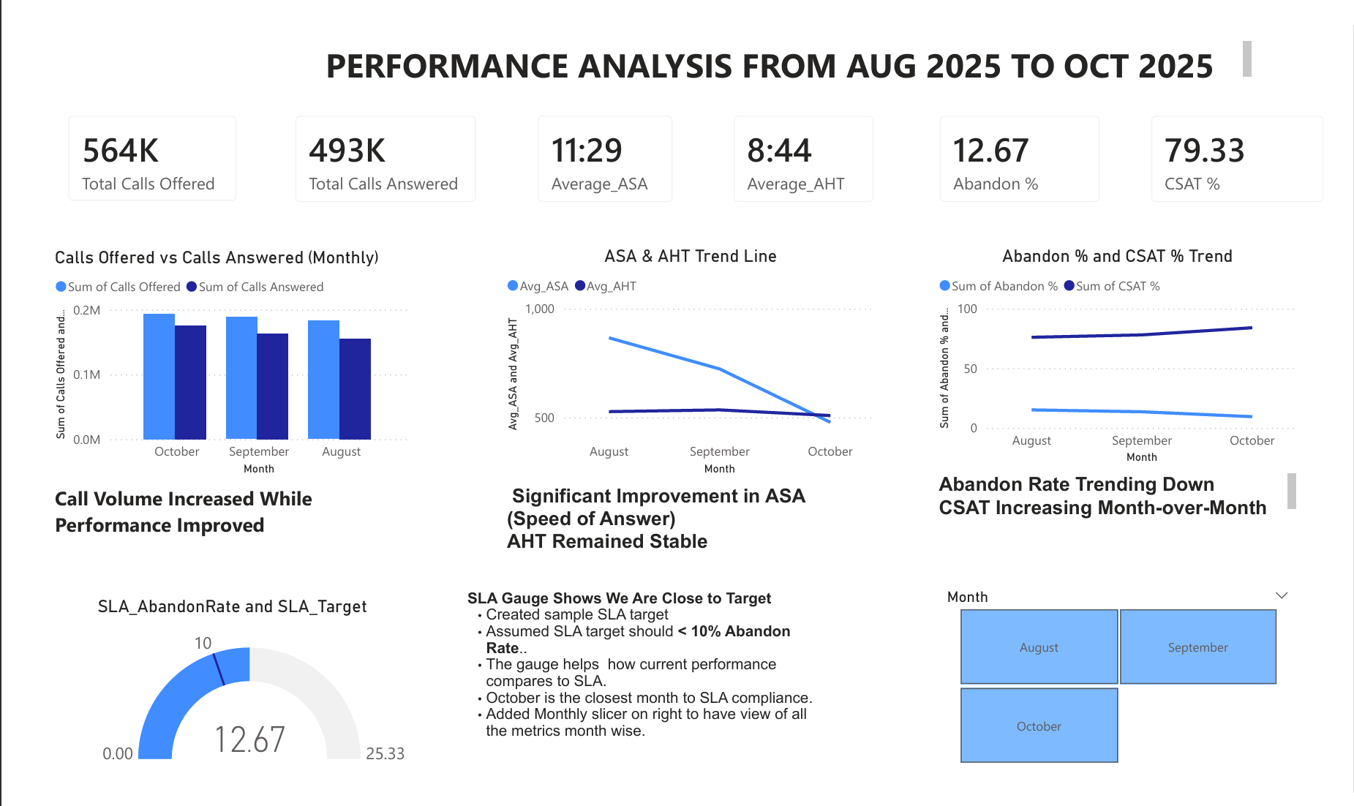
Call Volume
- Call volume increased steadily each month.
- The team successfully handled the rising volume with no backlog.
Service Efficiency (ASA & AHT)
- ASA improved significantly month-over-month, meaning customers waited less to reach an agent.
- AHT remained stable, showing agents handled calls consistently even with higher call traffic.
Customer Impact (Abandon % & CSAT)
- Abandon Rate decreased each month, falling below the SLA threshold in October.
- CSAT increased consistently, reaching the highest level in October.
- This confirms that faster answer times directly improved customer experience.
Overall Monthly Insight
October stands out as the strongest performance month, with the best ASA, lowest abandon rate, and highest CSAT.

2. Weekly Performance Summary
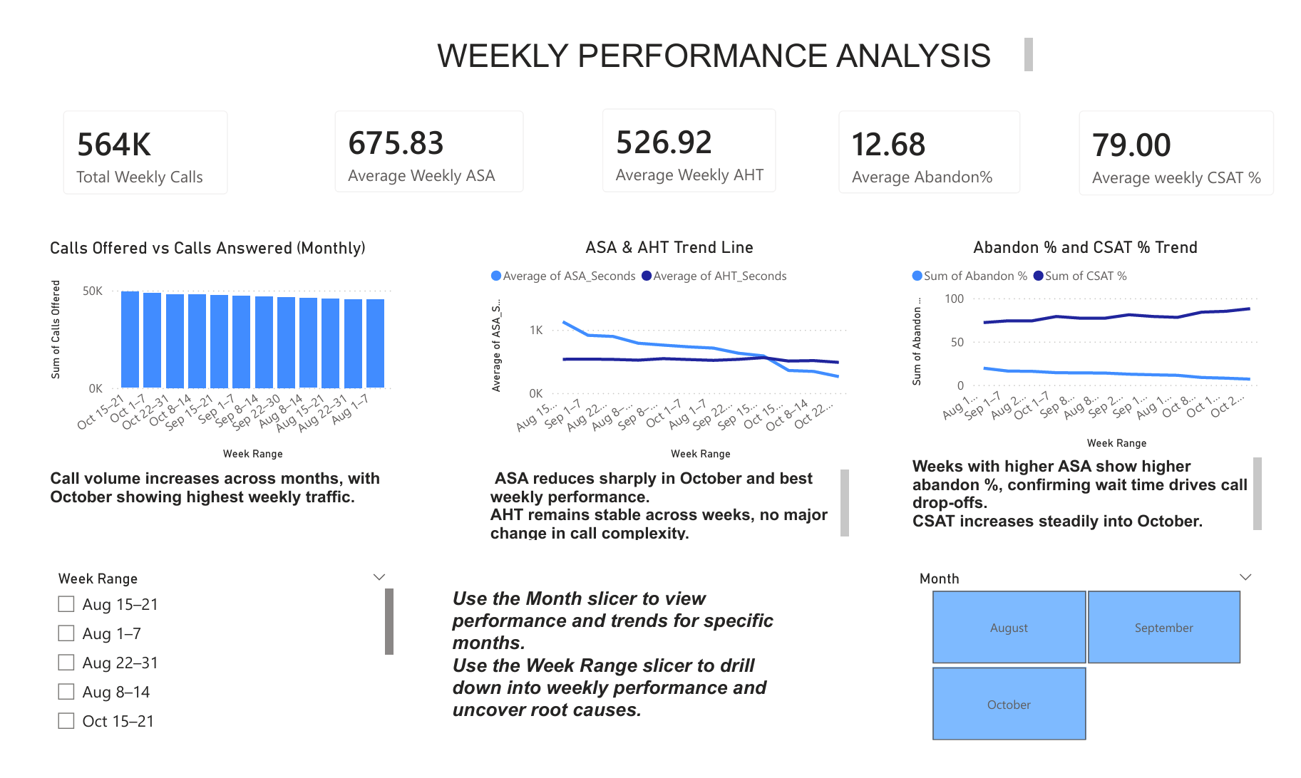
Weekly Call Patterns
- Weekly trends show clear peak periods, particularly in early October.
- Despite high traffic, the team maintained strong service levels.
Weekly ASA
- ASA improved dramatically during October weeks, showing operational efficiency gains.
Weekly AHT
- AHT remained stable week-to-week, indicating no major change in call complexity.
Weekly Abandon % & CSAT
- Higher ASA weeks aligned with increased abandon %, confirming wait time is the main driver.
- CSAT rose steadily as ASA improved, especially in October weeks.
Overall Weekly Insight
Weekly views help identify exactly which weeks drove improvements, allowing targeted operational decision-making.

3. Slicer-Based Interactivity
The dashboard includes slicers for Month and Week Range, allowing leadership to:
- Drill into specific periods
- Compare trends between months
- Identify peak weeks
- Understand root causes for performance shifts
This makes the dashboard interactive, customizable, and highly actionable.

4. Key Performance Shifts Identified
- 📈 Rising call volumes without service slowdown
- ⚡ Major improvement in ASA driving customer satisfaction
- 🟢 Abandon rate reduced below SLA by October
- ⭐ CSAT improved across all periods
- 🔄 AHT stability showing consistent agent handling
- 🏆 October emerged as the benchmark month for performance

5. Final Summary
The dashboard reveals strong operational progress across the three months.
Even with increasing call demand, the customer service team improved efficiency, reduced customer wait times, lowered abandon rates, and increased customer satisfaction.
This reporting concept gives leadership a clear, interactive, and insightful view of performance shifts, making it easier to guide decisions and support continuous improvement.

